# OpenFOAM (Open-Source Version) Instructions for Use

## I. Instructions before calculation

1. This example is based on OpenFOAM-9, so please install OpenFOAM-9 before calculating this example;
2. Copy the folder "spatterBehaviorPredictSLM_CaoLiu" to any local location.

## II. Running example

The folder "spatterBehaviorPredictSLM_CaoLiu" is the example for calculating SLM spatter. Enter the folder "fspatterBehaviorPredictSLM_CaoLiu", run ". /Allrun" to start the multi-core calculation (if it doesn't work, please run "chmod +x Allrun" first, then run ". /Allrun"). Here is the use of 48-core calculation, if there is no 48-core, you need to modify the file "spatterBehaviorPredictSLM_CaoLiu\system\decomposeParDict" and "Allrun" file.

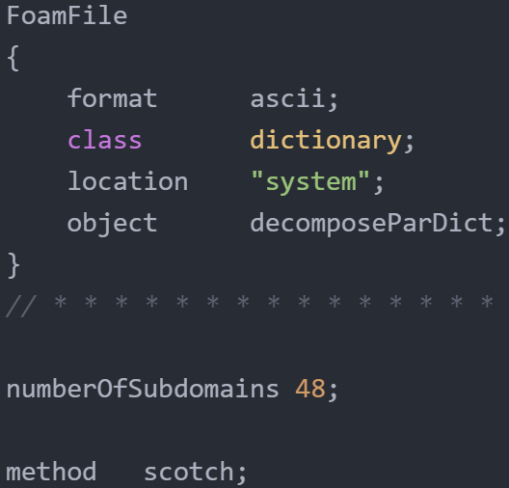

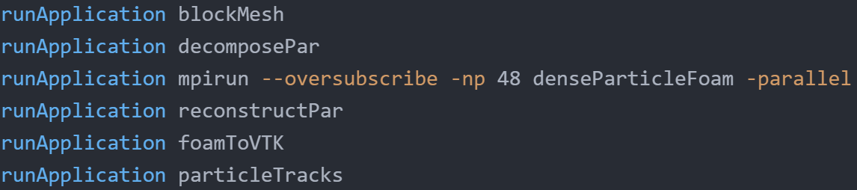

The results of the calculation are as follows:

